**1.1: Data Query Language**

1. List the Name and Designation code of the staff who have joined before Jan 2003 and whose salary range is between 12000 and 25000. Display the columns with user defined Column headers. Hint: Use As clause along with other operators

**select Staff_Name as Name ,Design_Code as DesignationCode from staff_masters where (Hiredate < '2003-01-01') and Staff_sal between 12000 and 25000;**

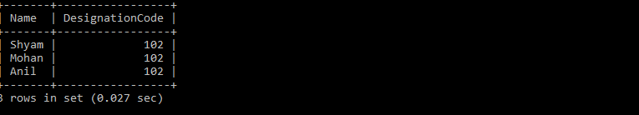

2. List the staff code, name, and department number of the staff who have experience of 18 or more years and sort them based on their experience

**MariaDB [RDBMS]> select Staff_code,Staff_name,Dept_Code from staff_masters where 18>=floor(datediff(curdate(),Hiredate))/365 order by Hiredate;**

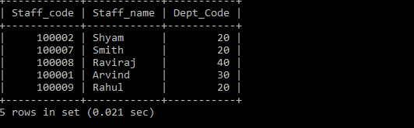

3. Display the staff details who do not have manager. Hint: Use is null

**MariaDB [RDBMS]> select * from staff_masters where Mgr_code is null;**



4. Display the Book details that were published during the period of 2001 to 2004. Also display book details with Book name having the character ‘&’ anywhere.

**MariaDB [RDBMS]> select * from book_masters where (Book_pub_year between 2001 and 2004) or Book_Name like "%&%";**

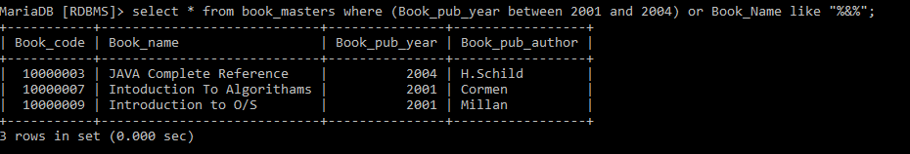

5. List the names of the staff having ‘_’ character in their name.

**MariaDB [RDBMS]> select Staff_name from staff_masters where Staff_name like "%\_%";**



**2.1: Single Row Functions:**

1. Create a query which will display Staff Name, Salary of each staff. Format the salary to be 15 characters long and left padded with ‘$’.

**MariaDB [RDBMS]> select staff_Name,lpad(Staff_sal,10,'$') as StaffSalary from Staff_masters;**

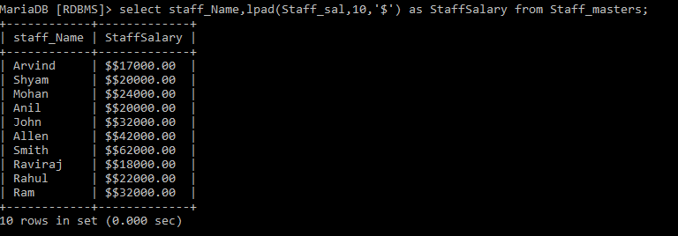

2. Display name and date of birth of students where date of birth must be displayed in the format similar to “January, 12 1981” for those who were born on Saturday or Sunday.

**MariaDB [RDBMS]> select Student_Name,date_format(Student_Dob,"%M, %d %Y") as dob from student_masters where date_format(Student_Dob,"%a") like 'SAT' or date_format(Student_Dob,"%a") like 'SUN';**

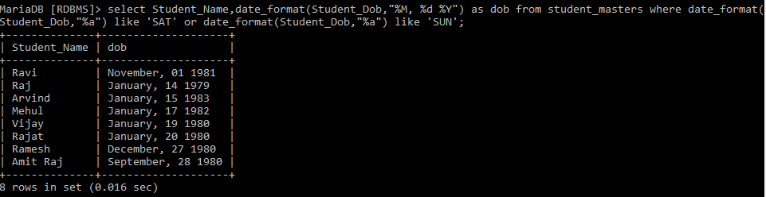

3. Display each Staff name and number of months they worked for the organization. Label the column as ‘Months Worked’. Order your result by number of months employed. Also Round the number of months to closest whole number.

**MariaDB [RDBMS]> select Staff_Name, round(datediff(curdate(),Hiredate)/365)*12 as Months_Worked from staff_masters order by round(datediff(curdate(),Hiredate)/365)*12 desc;** 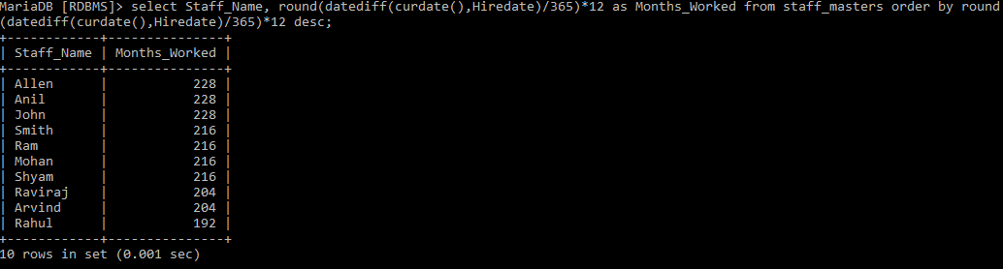

4. List the details of the staff who have joined in first half of December month (irrespective of the year).

**MariaDB [RDBMS]> select * from staff_masters where day(Hiredate)<=15 and month(Hiredate)=12;**

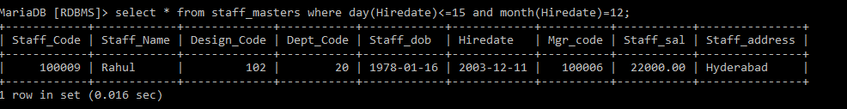

5. Write a query that displays Staff Name, Salary, and Grade of all staff. Grade depends on the following table.

Salary Grade Salary >=50000 A

Salary >= 25000 < 50000 B

Salary>=10000 < 25000 C

OTHERS D

**MariaDB [RDBMS]> select Staff_Name,Staff_sal, case when Staff_sal>=50000 then 'A' when Staff_sal>=25000 and Staff_sal<50000 then 'B' when Staff_sal>=10000 and Staff_sal <25000 then 'C' else 'D' end as Grade from staff_masters;**

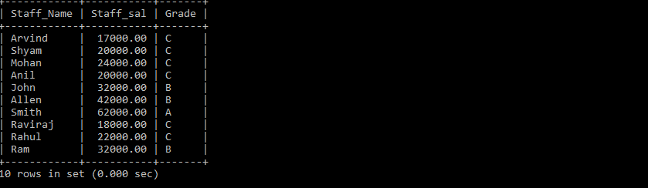

7. Write a query to find the position of third occurrence of ‘i’ in the given word ‘Mississippi’.

**MariaDB [RDBMS]> select length(substring_index("Mississippi",'i',3))+1 ;**

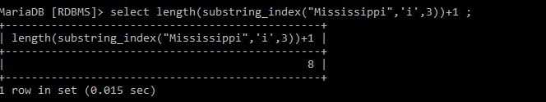

8. Write a query to find the pay date for the month. Pay date is the last Friday of the month. Display the date in the format “Twenty Eighth of January, 2002”. Label the heading as PAY DATE. Hint: use to_char, next_day and last_day functions

9. Display Student code, Name and Dept Name. Display “Electricals” if dept code = 20, “Electronics” if Dept code =30 and “Others” for all other Dept codes in the Dept Name column. Hint : Use Decode

**MariaDB [RDBMS]> select Student_Code,Student_Name, case when Dept_Code=20 then "Electricals" when Dept_Code=30 then "Electronics" else "Others" end as Dept_Name from student_masters;**

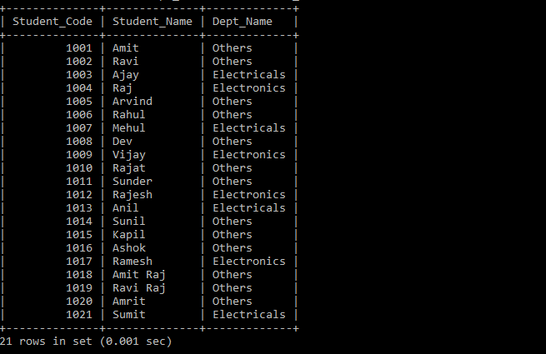

**2.2: Group Functions:**

1. Display the Highest, Lowest, Total & Average salary of all staff. Label the columns Maximum, Minimum, Total and Average respectively for each Department code. Also round the result to the nearest whole number.

**MariaDB [RDBMS]> select round(max(Staff_sal)) as Maximum,round(min(Staff_sal)) as Minimum,round(sum(Staff_sal)) as Total,round(avg(Staff_sal)) as Average from staff_masters group by Dept_code;**

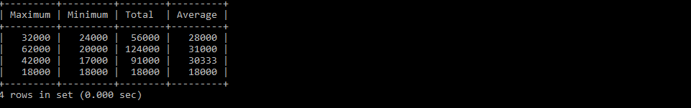

2. Display Department code and number of managers working in that department. Label the column as ‘Total Number of Managers’ for each department.

**MariaDB [RDBMS]> select Dept_Code,count(Mgr_code) as Total_number_of_managers from staff_masters group by Dept_Code;**

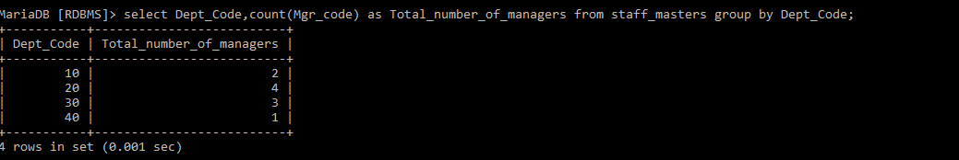

3.Get the Department number, and sum of Salary of all non-managers where the sum is greater than 20000.

**MariaDB [RDBMS]> select Dept_Code,sum(Staff_sal) as sum_salary from staff_masters where Staff_Code not in(select Mgr_code from staff_masters) group by Dept_Code having sum(Staff_sal)>20000;**

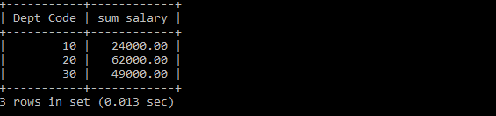

**3.1: Joins and Subqueries**

1. Write a query which displays Staff Name, Department Code, Department Name, and Salary for all staff who earns more than 20000.

**MariaDB [RDBMS]> select sm.Staff_Name,sm.Dept_code,sm.Staff_sal,dm.Dept_name from staff_masters sm,department_masters dm where sm.Dept_Code=dm.Dept_Code;**

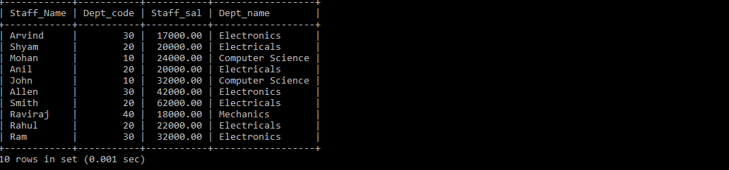

2. Display Staff Code, Staff Name, Department Name, and his manager’s number and name. Label the columns Staff#, Staff, Mgr#, Manager.

**MariaDB [RDBMS]> select sm.Staff_code as 'staff#',sm.Staff_Name as 'Staff',dm.Dept_name,sm.Mgr_code as 'Mgr#',sm1.Staff_Name as 'Mgr' from staff_masters sm ,staff_masters sm1 ,department_masters dm where sm.Dept_code=dm.Dept_Code and sm.mgr_code=sm1.Staff_code ;**

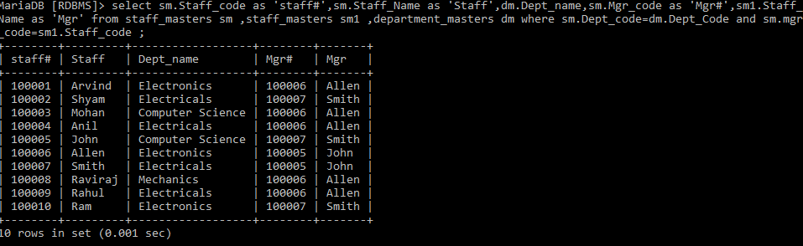

4. Create a query that will display Staff Code, Staff Name, Department Name, Designation name, Book Code, Book Name, and Issue Date for only those staff who have taken any book in last 30 days. . If required, make changes to the table to create such a scenario.

**MariaDB [RDBMS]> select stfm.staff_code,stfm.Staff_name,dm.Dept_name,dsgm.Design_name,bm.Book_code,bm.Book_name,bt.Book_issue_date from staff_masters stfm,Department_masters dm,Book_transactions bt,Book_masters bm,Designation_masters dsgm where stfm.Dept_code=dm.Dept_code and stfm.Design_code=dsgm.Design_code and bm.Book_code=bt.Book_code and bt.Staff_code=stfm.Staff_code and bt.Book_issue_date between subdate(curdate(),interval 30 day) and curdate();**



5. Generate a report which contains the following information.

Staff Code, Staff Name, Designation Name, Department, Book Code, Book Name,

Author, Fine For the staff who has not returned the book. Fine will be calculated as Rs. 5 per day.

Fine = 5 * (No. of days = Current Date – Expected return date). Include records in the table to suit this problem statement

**MariaDB [RDBMS]> select stfm.Staff_code,stfm.Staff_name,dsgm.Design_name,dm.dept_name,bm.book_code,bm.Book_name,bm.Book_pub_author, 5*datediff(curdate(),bt.Book_expected_return_date) as FINE from staff_masters stfm,Designation_masters dsgm,department_masters dm,book_masters bm,book_transactions bt where dsgm.Design_code=stfm.Design_code and dm.dept_code=stfm.Dept_code and bt.Staff_code=stfm.Staff_code and bt.book_code=bm.Book_code;**

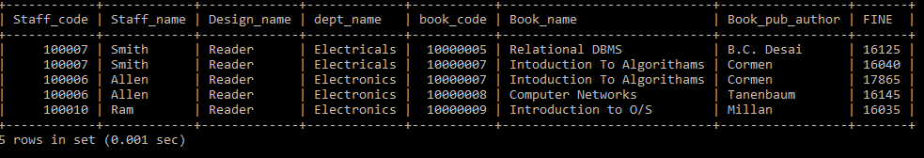

6. List Staff Code, Staff Name, and Salary for those who are getting less than the average salary of organization.

**MariaDB [RDBMS]> select stfm.Staff_code,stfm.Staff_name,stfm.Staff_sal from staff_masters stfm where Staff_sal<(select avg(staff_sal) from Staff_masters);**

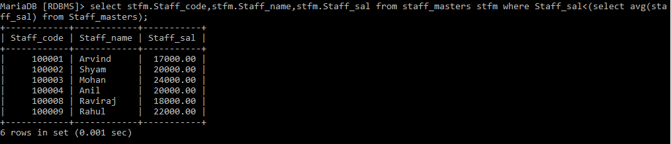

7. Display Author Name, Book Name for those authors who wrote more than one book

**MariaDB [RDBMS]> select Book_pub_author,book_name from book_masters where book_pub_author=(select book_pub_author from book_masters group by book_pub_author having count(*)>1);**



8. Display Staff Code, Staff Name, and Department Name for those who have taken more than one book.

**MariaDB [RDBMS]> select stfm.Staff_code,stfm.staff_name,dm.Dept_name from staff_masters stfm,department_masters dm,book_transactions bt where stfm.dept_code=dm.dept_code and stfm.staff_code=bt.staff_code group by bt.staff_code having count(*)>1;**

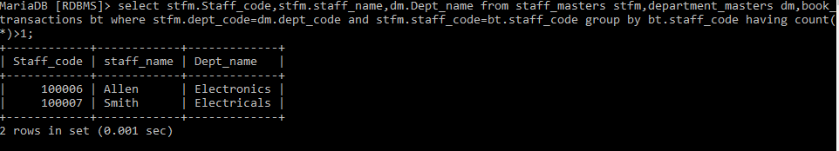

9. Display the Student Code, Student Name, and Department Name for that department in which there are maximum number of student studying

**MariaDB [RDBMS]> select stdm.student_code,stdm.student_name,dm.dept_name from student_masters stdm,department_masters dm where stdm.Dept_code=dm.Dept_code order by count(stdm.dept_code) desc limit 1;**

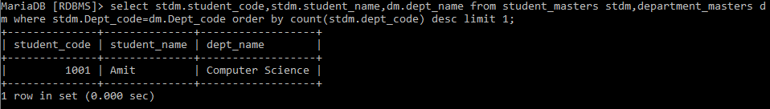

10. Display Staff Code, Staff Name, Department Name, and Designation name for those who have joined in last 3 months.

**MariaDB [RDBMS]> select stfm.staff_code,stfm.staff_name,dm.Dept_name,dsgm.Design_name from staff_masters stfm,department_masters dm,designation_masters dsgm where stfm.Design_code=dsgm.Design_code and stfm.Dept_code=dm.Dept_code and stfm.Hiredate between date_sub(curdate(),interval 3 month) and curdate();**



11. Display the Manager Name and the total strength of his/her team.

**MariaDB [RDBMS]> select s1.Staff_Name,count(s2.staff_code) as strength from staff_masters s1,staff_masters s2 where s2.Mgr_code=s1.staff_code group by s2.Mgr_code;**

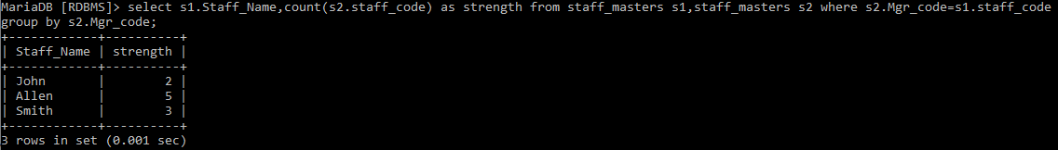

12. Display the details of books that have not been returned and expected return date was last Monday. Book name should be displayed in proper case.. Hint: You can change /add records so that the expected return date suits this problem statement.

**MariaDB [RDBMS]> select * from book_transactions bt,book_masters bm where bm.book_code=bt.book_code and bt.book_actual_return_date is null and curdate()-((7+weekday(curdate()))%7)=bt.book_expected_return_date;**



13. Write a query to display number of people in each Department. Output should display Department Code, Department Name and Number of People

**MariaDB [RDBMS]> select s.dept_code,dm.Dept_name,count(*) as Number from staff_masters s,student_masters s1,department_masters dm where s.dept_code=dm.dept_code and s1.dept_code=s.dept_code group by s.dept_code;**

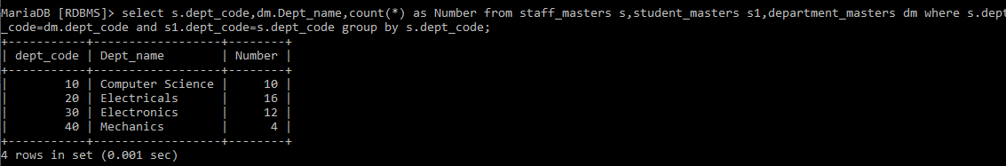

**4.1: Database Objects**

1. Create the Customer table with the following columns.

CustomerId int(5)

Cust_Name varchar(20)

Address1 Varchar(30)

Address2 Varchar(30)

**MariaDB [RDBMS]> create table Customer(CustomerId int(5),Cust_Name varchar(20),Address1 varchar(30),Address2 varchar(30));**

**Query OK, 0 rows affected (0.142 sec)**

2. Modify the Customer table Cust_Name column of datatype with Varchar2(30), rename the column to CustomerName and it should not accept Nulls.

**MariaDB [RDBMS]> alter table customer change Cust_name CustomerName varchar(30) not null;**

Query OK, 0 rows affected (0.304 sec)

Records: 0 Duplicates: 0 Warnings: 0

3. a) Add the following Columns to the Customer table.

Gender Varchar(1)

Age int(3)

PhoneNo int(10)

b) Rename the Customer table to Cust_Table

**MariaDB [RDBMS]> alter table customer add Gender varchar(1),add Age int(3),add PhoneNo int(10);**

Query OK, 0 rows affected (0.045 sec)

Records: 0 Duplicates: 0 Warnings: 0

**MariaDB [RDBMS]> alter table Customer rename to cust_table;**

Query OK, 0 rows affected (0.083 sec)

4. Insert rows with the following data in to the Customer table

Insert into customer values: (1000, ‘Allen’, ‘#115 Chicago’, ‘#115 Chicago’, ‘M’, ‘25, 7878776’)

In similar manner, add the below records to the Customer table:

1001, George, #116 France, #116 France, M, 25, 434524

1002, Becker, #114 New York, #114 New York, M, 45, 431525

**MariaDB [RDBMS]> alter table Customer rename to cust_table;**

**MariaDB [RDBMS]> insert into cust_table values(1001,'George','#116 France','#116 France','M',25,434524);**

**MariaDB [RDBMS]> insert into cust_table values(1002,'Becker','#114 New York','#114 New York','M',45,431525);** 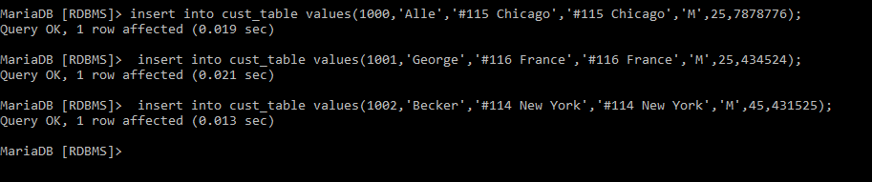

5. Add the Primary key constraint for Customerld with the name Custld_Prim.

**MariaDB [RDBMS]> alter table cust_table add constraint custid_prim primary key(customerid);**

6. Insert the row given below in the Customer table and see the message generated by the Oracle server.

1002, John, #114 Chicago, #114 Chicago, M, 45, 439525

**MariaDB [RDBMS]> insert into cust_table values(1002,'John','#114 Chicago','#114 Chicago','M',45,439525);**



7. Disable the constraint on CustomerId, and insert the following data:

1002, Becker, #114 New York, #114 New york , M, 45, 431525

1003, Nanapatekar, #115 India, #115 India , M, 45, 431525

**MariaDB [RDBMS]> alter table cust_table drop primary key;**

**insert into cust_table values(1002,'Becker','#114 New York','#114 New York','M',45,431525);**

**MariaDB [RDBMS]> insert into cust_table values(1003,'Nanapatekar','#114 India','#114 India','M',45,431525);**

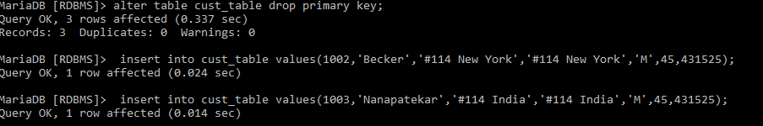

8. Enable the constraint on CustomerId of the Customer table, and see the message generated by the Oracle server.

**MariaDB [RDBMS]> alter table cust_table add constraint custid_prim primary key(customerid);**

9. Drop the constraint Custld_Prim on CustomerId and insert the following Data. Alter Customer table, drop constraint Custid_Prim.

1002, Becker, #114 New York, #114 New york , M, 45, 431525, 15000.50

1003, Nanapatekar, #115 India, #115 India , M, 45, 431525, 20000.50

**MariaDB [RDBMS]> insert into cust_table values(1002,'Becker','#114 New York','#114 New York','M',45,431525);**

**MariaDB [RDBMS]> insert into cust_table values(1002,'John','#114 Chicago','#114 Chicago','M',45,439525);**

10. Delete all the existing rows from Customer table, and let the structure remain itself using TRUNCATE statement.

**MariaDB [RDBMS]> truncate table cust_table;**

11. In the Customer table, add a column E_mail.

**MariaDB [RDBMS]> alter table cust_table add e_mail varchar(50);**



12. Drop the E_mail column from Customer table.

**MariaDB [RDBMS]> alter table cust_table drop e_mail;**

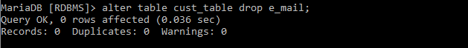

13. Create the Suppliers table based on the structure of the Customer table. Include only the CustomerId, CustomerName, Address1, Address2, and phoneno columns.

Name the columns in the new table as SuppID, SName, Addr1, Addr2, and Contactno respectively.

**MariaDB [RDBMS]> create table suppliers(suppId int(5),sname varchar(50),addr1 varchar(20),addr2 varchar(20),contactno int(10));**

14. Drop the above table and recreate the following table with the name CustomerMaster.

CustomerId int(5) Primary key(Name of constraint is CustId_PK)

CustomerName Varchar(30) Not Null

Addressl Varchar(30) Not Null

Address2 Varchar(30)

Gender Varchar(l)

Age int(3)

PhoneNo int(10)

**MariaDB [RDBMS]> create table customermaster(customerid int(5),customerName varchar(30) not null,address1 varchar(30) not null,address2 varchar(30),gender varchar(1),age int(3),phoneNo int(10),constraint custid_pk primary key(customerid));**

15. Create the AccountsMaster table with the following Columns. Use auto generate to generate Account number

Customerld int(5)

AccountNumber int(10,2) Primary key(Name of constraint is Acc_PK)

AccountType Char(3)

LedgerBalance int(10,2) Not Null

**MariaDB [RDBMS]> create table accountsmaster(customerid int(5),accountNumber double(10,2) not null auto_increment,accountType char(3),Ledgerbalance decimal(10,2) not null,constraint acc_pk primary key(accountNumber));**

16. Relate AccountsMaster table and CustomerMaster table through Customerld column with the constraint name Cust_acc.

**MariaDB [RDBMS]> alter table accountsmaster add constraint fk_cid foreign key(customerid) references customermaster(customerid);**

Query OK, 0 rows affected (0.341 sec)

Records: 0 Duplicates: 0 Warnings: 0

17. Insert the following rows to the CustomerMaster table:

1000, Allen, #115 Chicago, #115 Chicago, M, 25, 7878776

1001, George, #116 France, #116 France, M, 25, 434524

1002, Becker, #114 New York, #114 New York, M, 45, 431525

**MariaDB [RDBMS]> insert into customermaster values(1000,'Allen', '#115 Chicago','#115 Chicago','M',25,7878776);**

**MariaDB [RDBMS]> insert into customermaster values(1001,'George', '#116 France','#116 France','M',25,434524);**

**MariaDB [RDBMS]> insert into customermaster values(1002,'Becker', '#114 New York','#114 New York','M',45,431525);**

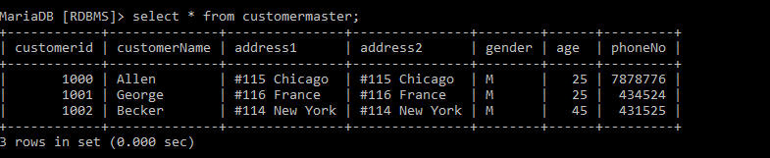

18. Modify the AccountMaster table with the Check constraint to ensure AccountType should be either NRI or IND.

**MariaDB [RDBMS]> alter table accountsmaster add constraint chk_at check(AccountType in('NRI','IND'));**

19. Modify the AccountsMaster table keeping a Check constraint with the name Balance_Check for the Minimum Balance which should be greater than 5000.

**MariaDB [RDBMS]> alter table accountsmaster add constraint Balance_Check check(ledgerbalance>5000);**

20. Modify the AccountsMaster table such that if Customer is deleted from Customer table then all his details should be deleted from AccountsMaster table.

**MariaDB [RDBMS]> alter table accountsmaster drop constraint fk_cid;**

**MariaDB [RDBMS]> alter table accountsmaster add constraint fk_cid foreign key(customerid) references customermaster(customerid) on delete cascade;**

21. Create Backup copy for the AccountsMaster table with the name ‘AccountDetails’.

**MariaDB [RDBMS]> create table accountdetails as select * from accountsmaster;**

22. Create a view ‘Acc_view’ with columns Customerld, CustomerName, AccountNumber, AccountType, and LedgerBalance from AccountsMaster. In the view Acc_view, the column names should be CustomerCode, AccountHolderName, AccountNumber, Type, and Balance for the respective columns from AccountsMaster table.



**MariaDB [RDBMS]> create view acc_view as(select cm.customerid as customercode,cm.customername as accountholdername,am.accountnumber,am.accounttype as Type,am.ledgerbalance as Balance from accountsmaster am,customermaster cm);**



23. Create a view on AccountsMaster table with name vAccs_Dtls. This view should list all customers whose AccountType is ‘IND’ and their balance amount should not be less than 10000. Using this view any DML operation should not violate the view conditions.

**MariaDB [RDBMS]> create or replace definer=current_user sql security definer view vAccs_Dtls as(select * from accountsmaster where accounttype like 'IND' and ledgerbalance>=10000);**

**Query OK, 0 rows affected (0.018 sec)**



24. Create a view accsvw10 which will not allow DML statement against it.

**MariaDB [RDBMS]> create or replace definer=current_user sql security definer view accsvw10 as (select * from accountsmaster);**  


25. Insert three sample rows by using the above auto generate in Department_Masters table

**MariaDB [RDBMS]> insert into department_masters(dept_name) values ('ECE');**

**MariaDB [RDBMS]> insert into department_masters(dept_name) values ('EEE');**

**MariaDB [RDBMS]> insert into department_masters(dept_name) values ('IT');**

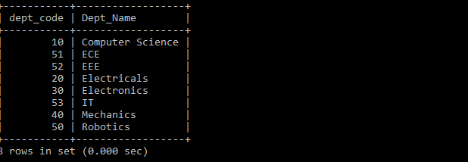

29. Note: Perform this after creating the Employee Table mentioned in the next Lab assignment. Create Index on HireDate column and give the name as idx_emp_hiredate for this object.Data Manipulation Language

**MariaDB [RDBMS]> create index idx_emp_hiredate on emp(Hiredate);**

**5.1: Data Manipulation Language**

1. Create Employee table with same structure as EMP table.

SQL>Create table employee as select * from emp where 1=3

SQL>desc employee

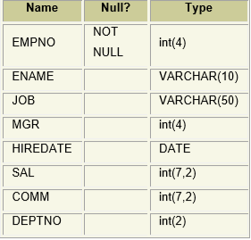

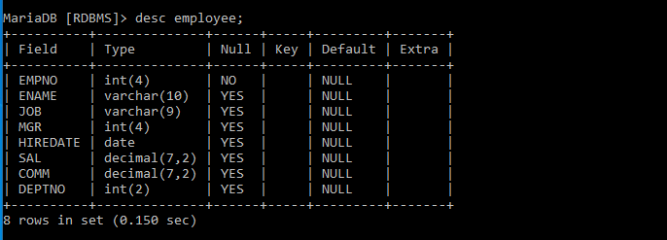

2. Write a query to populate Employee table using EMP table’s empno, ename, sal, deptno columns.

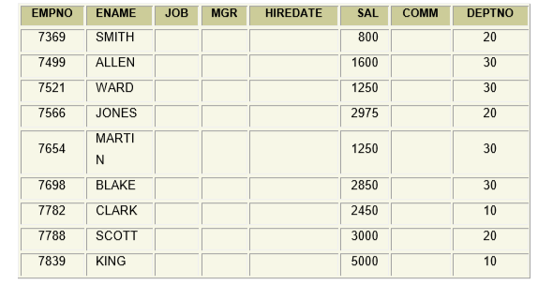

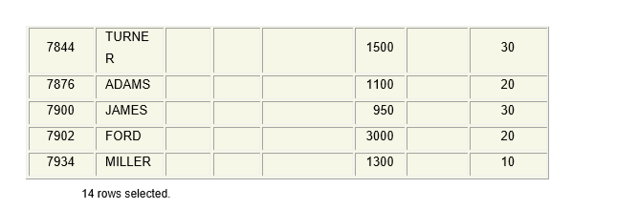

**insert into employee(empno,ename,sal,deptno) values(7369,'SMITH',800,20);**

**insert into employee(empno,ename,sal,deptno) values(7499,'ALLEN',1600,30);**

**insert into employee(empno,ename,sal,deptno) values(7521,'WARD',1250,30);**

**insert into employee(empno,ename,sal,deptno) values(7566,'JONES',2975,20);**

**insert into employee(empno,ename,sal,deptno) values(7654,'MARTIN',125,30);**

**insert into employee(empno,ename,sal,deptno) values(7698,'BLAKE',2850,30);**

**insert into employee(empno,ename,sal,deptno) values(7782,'CLARK',2450,10);**

**insert into employee(empno,ename,sal,deptno) values(7788,'SCOTT',3000,20);**

**insert into employee(empno,ename,sal,deptno) values(7839,'KING',5000,10);**

**insert into employee(empno,ename,sal,deptno) values(7844,'TURNER',1500,30);**

**insert into employee(empno,ename,sal,deptno) values(7876,'ADAMS',1100,20);**

**insert into employee(empno,ename,sal,deptno) values(7900,'JAMES',950,30);**

**insert into employee(empno,ename,sal,deptno) values(7902,'FORD',3000,20);**

**insert into employee(empno,ename,sal,deptno) values(7934,'MILLER',1300,10);**

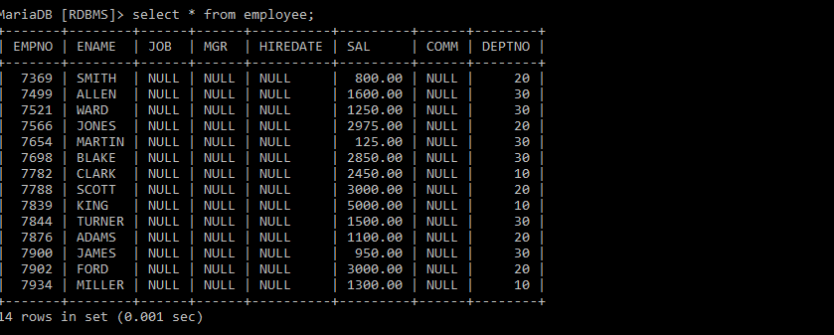

3. Write a query to change the job and deptno of employee whose empno is 7698 to the job and deptno of employee having empno 7788

**MariaDB [RDBMS]> update employee set deptno=(select deptno from employee where empno=7788),job=(select job from employee where empno=7788) where empno=7698;**

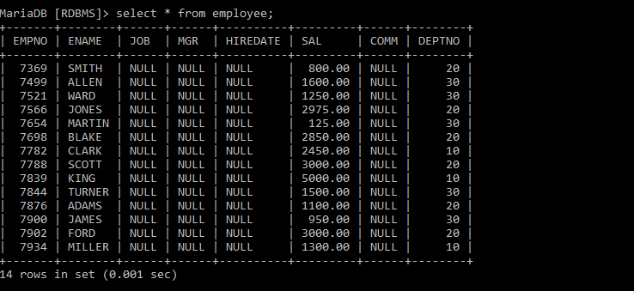

5. Write a query to change the deptno of employee with empno 7788 to that of employee having empno 7698.

**MariaDB [RDBMS]> update employee set deptno=(select deptno from employee where empno=7698) where empno=7788;**

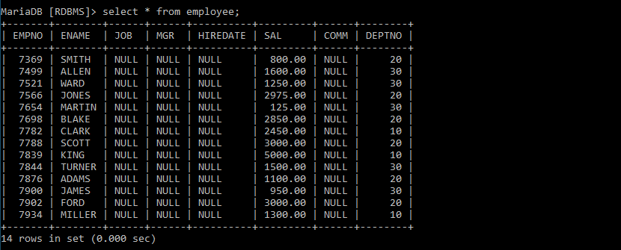

6. Insert the following rows to the Employee table through parameter substitution. • 1000,Allen, Clerk,1001,12-jan-01, 3000, 2,10 • 1001,George, analyst, null, 08 Sep 92, 5000,0, 10 • 1002, Becker, Manager, 1000, 4 Nov 92, 2800,4, 20 • 1003, 'Bill', Clerk, 1002, 4 Nov 92,3000, 0, 20

**insert into employee values(1001,'George', 'analyst', null, '1992-09-08', 5000,0, 10);**

**insert into employee values( 1002, 'Becker',' Manager', 1000, 1992-11-04', 2800,4, 20);**

**insert into employee values(1003, 'Bill', 'Clerk', 1002, '1992-11-04',3000, 0, 20);**

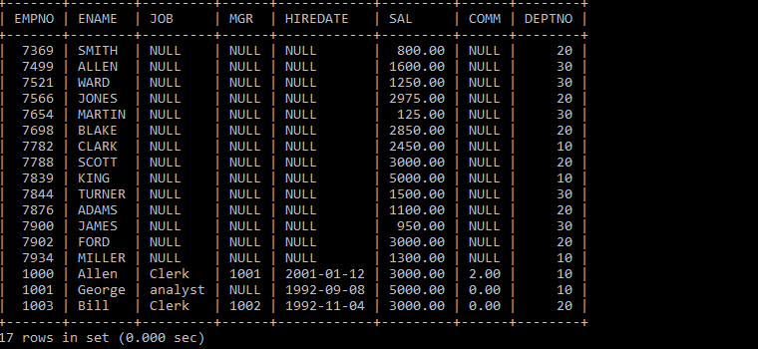

1. Insert rows with the following data into the Customer table. 6000, John, #115 Chicago, #115 Chicago, M, 25, 7878776, 10000 • 6001, Jack, #116 France, #116 France, M, 25, 434524, 20000 • 6002, James, #114 New York, #114 New York, M, 45, 431525, 15000.50

Use parameter substitution

**MariaDB [RDBMS]> insert into customermaster values(6000,'John',' #115 Chicago','#115 Chicago','M',25,7878776),(6001,'Jack','#116 France','#116 France','M',25,434524),(6002,'James','#114 New York','#114 New York','M',25,431525);**

2. Create a Savepoint named ‘SP1’ after third record in the Customer table .

**MariaDB [RDBMS]> savepoint sp1 ;**

**Query OK, 0 rows affected (0.000 sec)**